Cairo University Faculty of Computers and Artificial Intelligence



**Software design specification document**

**2023**

**Project Team**

|  |  |  |
| --- | --- | --- |
| **ID** | **Name** | **Email** |
| 20210605 | Badr Mohamed Ragab Elsaid | [badrmohmamedragab2003@gmail.com](mailto:badrmohmamedragab2003@gmail.com) |
| 20211079 | Mohamed Amir Mohamed | Me.mohamed.amir@gmail.com |
| 20211010 | Ahmed Yasser Mohamed | ahmed.yasser7937@gmail.com |
| 20211059 | Abdelrahman Adel Abdelazim | aboadel1512003@gmail.com |

Contents

Class diagram design 2

Class diagram Explanation 3

Sequence diagram design 4

GitHub repository link 7

# Class diagram design



# Class diagram Explanation

|  |  |  |  |
| --- | --- | --- | --- |
|  | Design Patterns | Justification | ParticipatingClasses |
| 1 | Strategy patterns | To change account type in runtime, depend on the choice of the user and make the design extendable | Account, BankAccount, WalletAccount |
| 2 | Factory Method | To separate the complex creation of the Account from instapay System | Registration, RegisterUsingWalletAccount, RegisterUsingBankAccount |
| 3 | Strategy patterns | To change transfer method in runtime, depend on the choice of the user and make the design extendable | TransferToInstapayAccount, TransferToBankAccount and TransferToWalletAccount |
| 4 | Strategy patterns | To change API type in runtime, depend on the choice of the user and make the design extendable | API, WalletAPI and BankAPI |
| 5 | Strategy patterns | To change Provider type in runtime, depend on the choice of the user and make the design extendable | Provider, Bank and Wallet |
| 6 | Strategy patterns | To change Wallet type in runtime, depend on the choice of the user and make the design extendable | Wallet, EtisalatWallet and VodafoneWallet |
| 7 | Strategy patterns | To change Bank type in runtime, depend on the choice of the user and make the design extendable | Bank, MasrBank, CIBBank and ElahlyBank |
| 8 | Strategy patterns | To change Bill type in runtime, depend on the choice of the user and make the design extendable | Bill, GasBill, WaterBill and ElectricityBill |
| 9 | Strategy patterns | To change Database type, and make the design extendable | DBConnection, DBHandle and ListDB |

# Sequence diagram design

* Sequence diagram for Pay Bills 🡪 Mohamed Amir

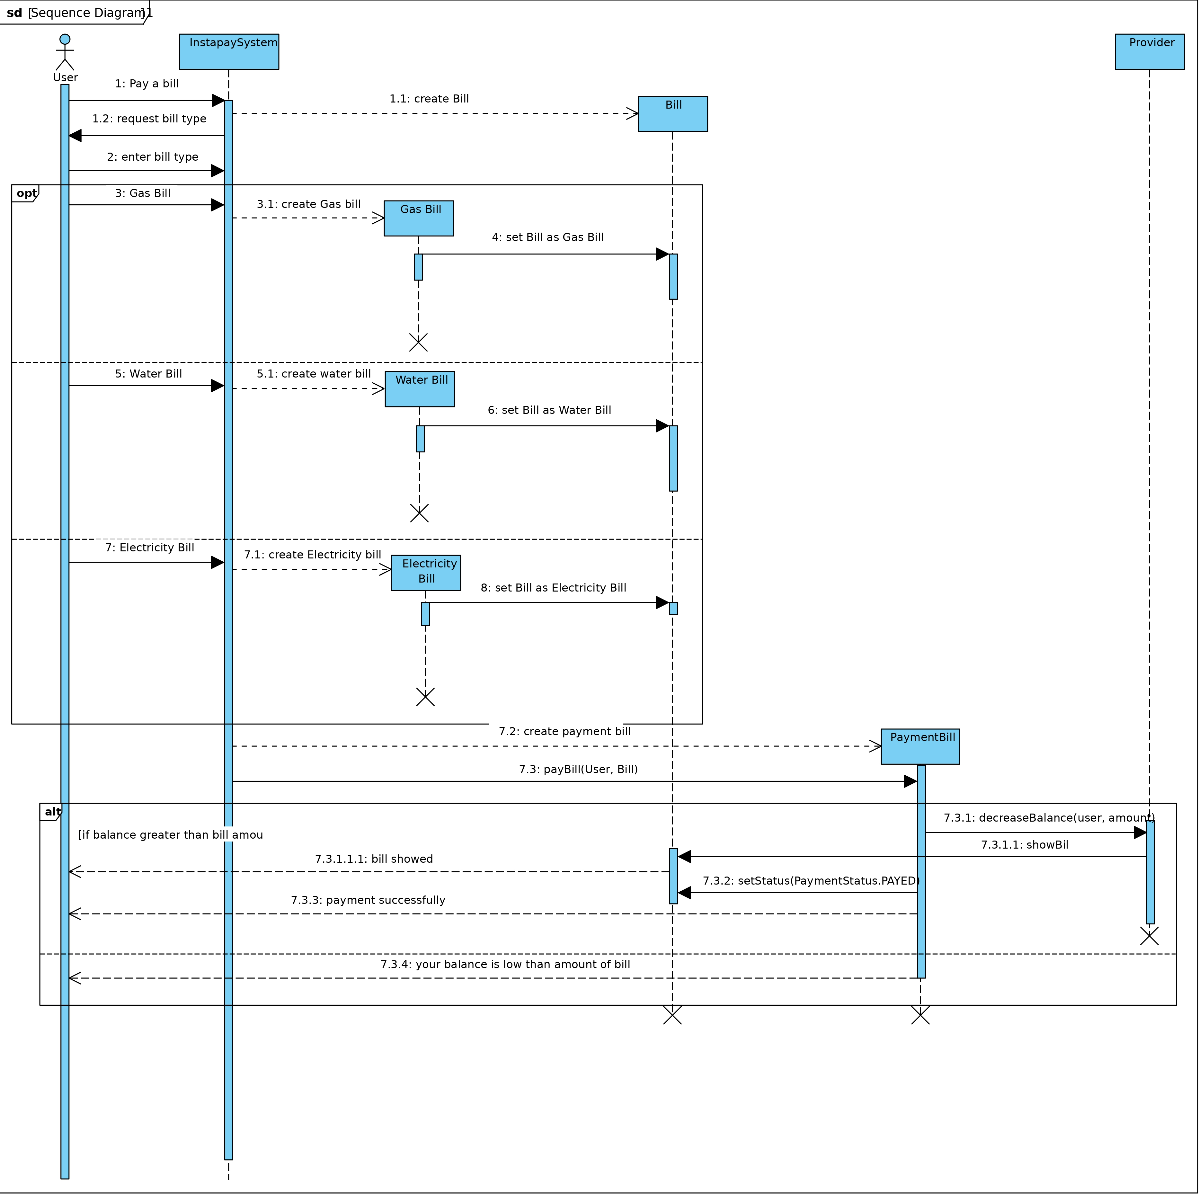

* Sequence diagram for Transfer to wallet 🡪 Badr Mohamed

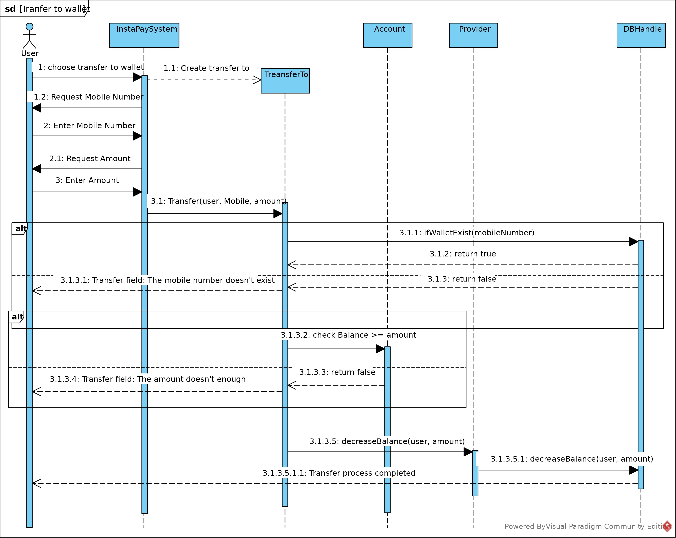

* 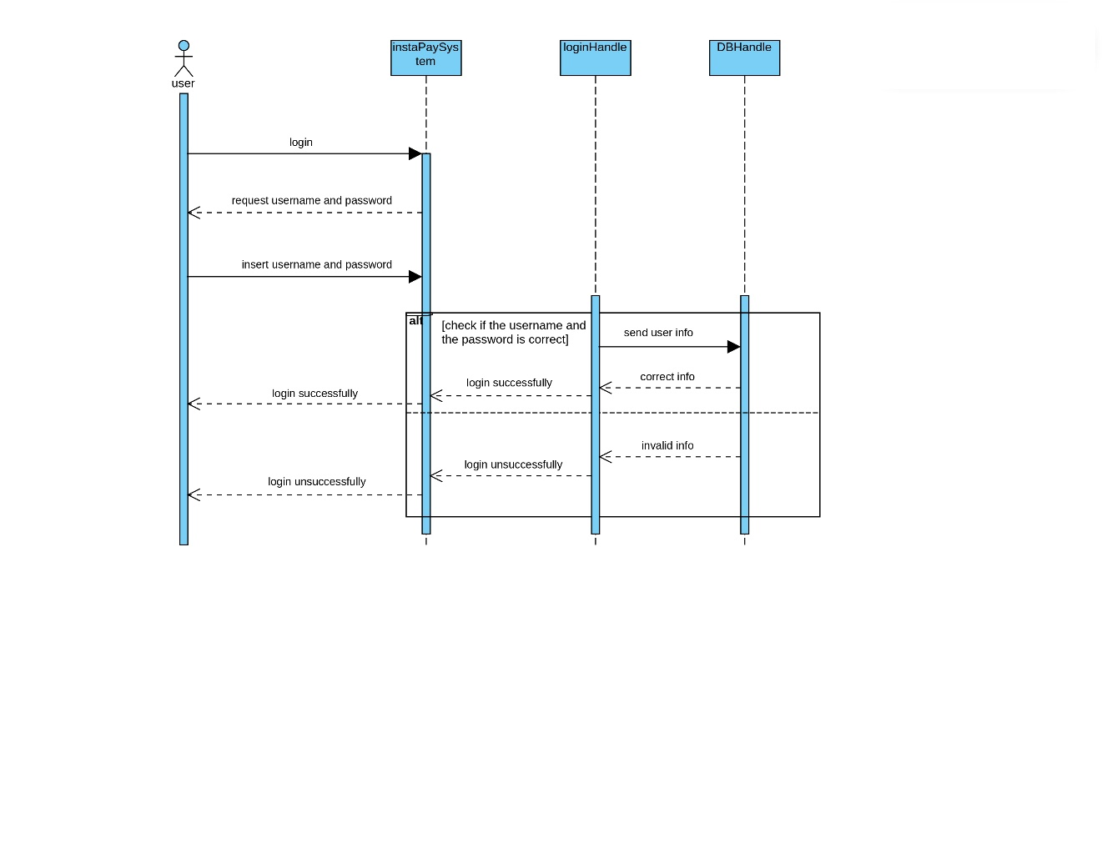Sequence diagram for Login 🡪 Abdelrahman Adel
* 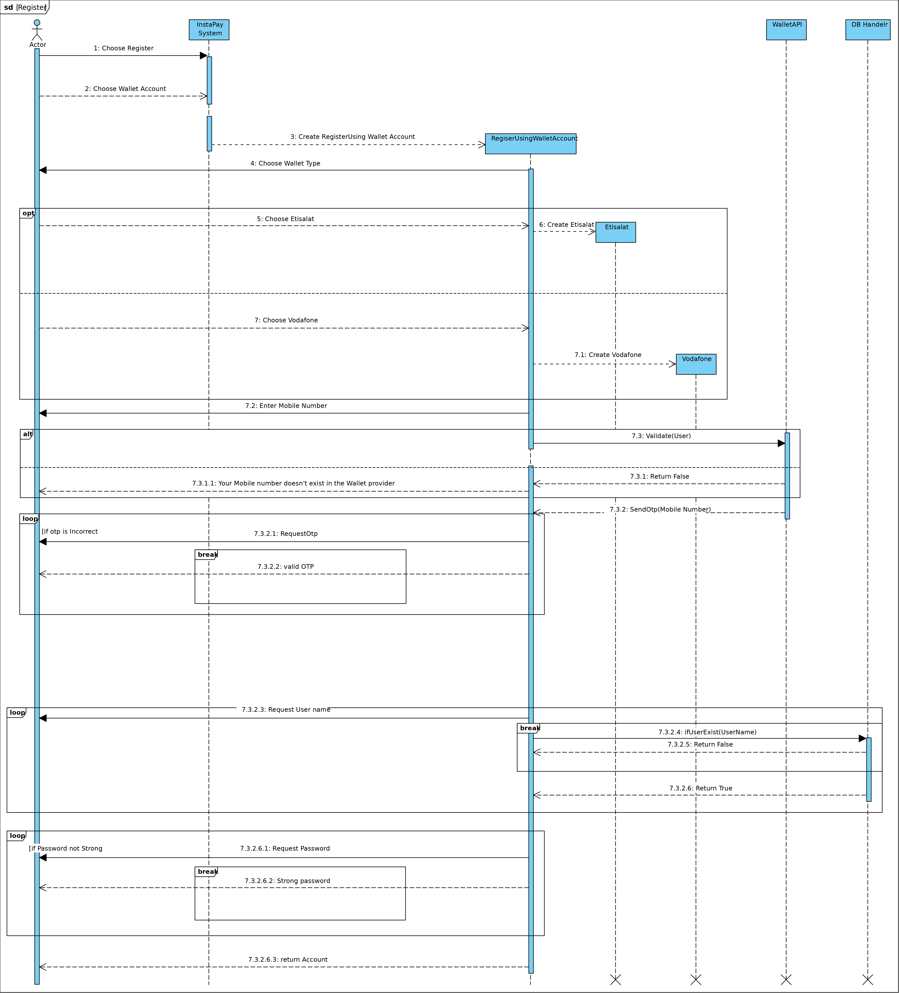Sequence diagram for Register Using Wallet Account 🡪 Ahmed Yasser Mohamed

# GitHub repository link

* https://github.com/Badrmohamedragab/InstaPay_Project